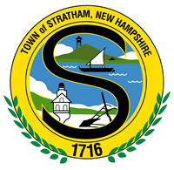

NOTICE OF PUBLIC MEETING
Pedestrian and Cyclist Advocacy Ad-hoc Committee
Friday August 25, 2019

8:30am

Municipal Center
10 Bunker Hill Ave.
Stratham, NH

Agenda

- Guinea Rd. intersections - follow up on discussion from previous meeting
- Brainstorming session - Safe Routes to School
- Budget 2020 process - follow up on recommended SRTS projects
- Update on Gateway District meeting
- Update on Master Plan
- Other
- Public Comment

