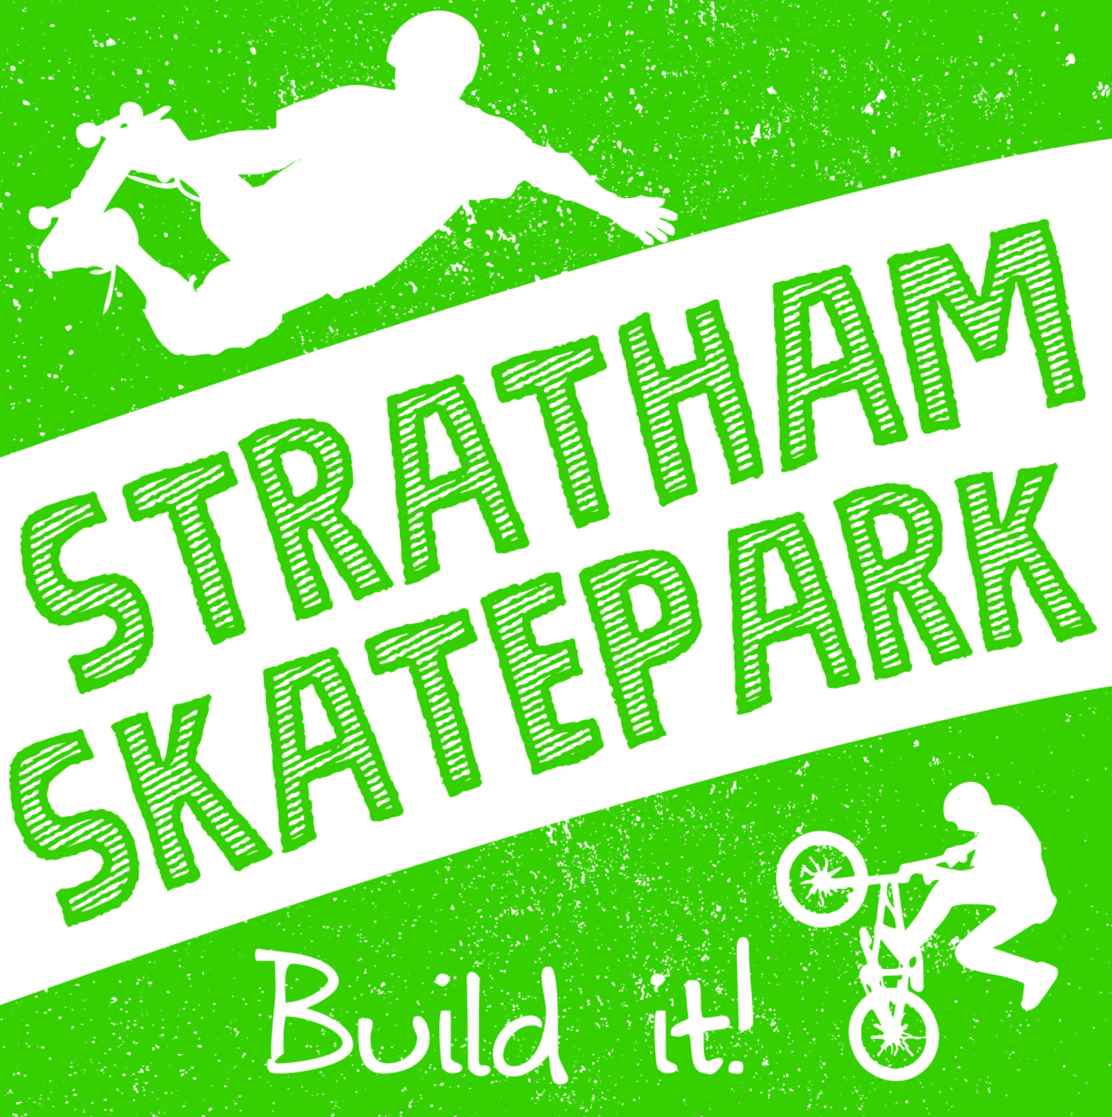 |  | 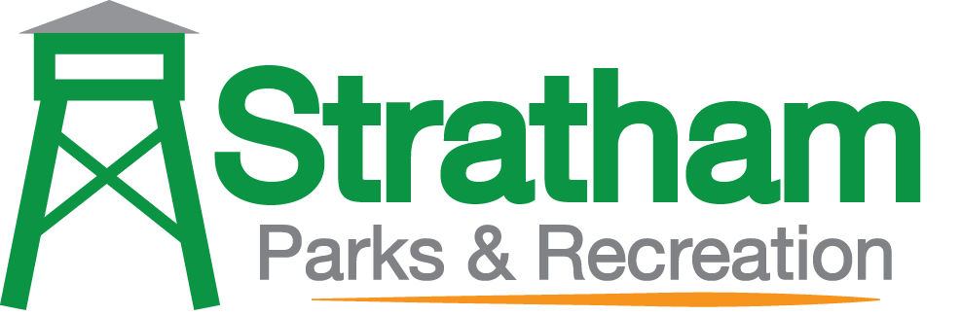
 |  | Business sponsorship Levels

Sponsorship Opportunities
Over the course of this next year the Stratham Skatepark Committee is hoping to raise money through various fundraising platforms in order to minimize tax payer contribution. We are hopeful to begin building the roughly 7,500 sq ft park in May 2019. To complete the project we estimate that we will need roughly $265,000. Whether you bike, scoot, skate, inline, or ride a unicycle you are an athlete and you are DESERVING of an amazing, safe place to practice your sport.
Thank you for your support and belief in the project.
Wondering where the funds that are raised will go? All money raised will go directly to the Town of Stratham under the Parks and Recreation Department.
*more about the project on back

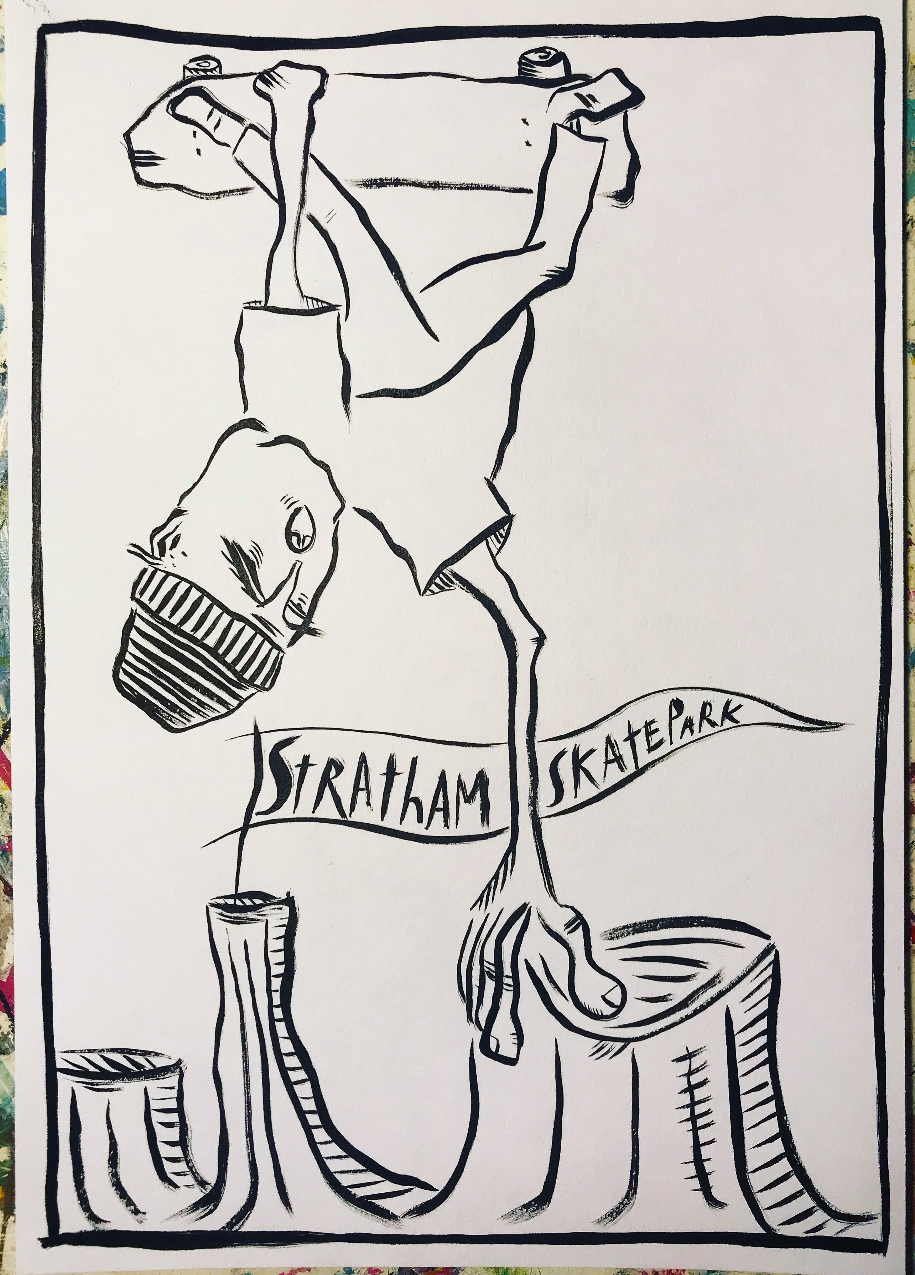
Wear Your Support
Purchase one of these t-shirts and wear your support with pride! T-Shirts come in sizes YM-Adult XL and are $20 each. Email us at 03sk885@gmial.com if you are interested in purchasing one
Cement Your Support
Would you like to see your gift for years to come?
Bricks are available in 4’x8’, 8’x8’, and 12’x12’ and can even include your company logo! www.polarengraving.com/StrathamSkateparkProject to order your brick today! Prices range from $100-$600
Socialize Your Support
Just want to make a contribution? Visit https://www.gofundme.com/stratham-skatepark-project
And once you’ve donated please share the campaign on your social media!
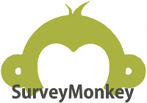
Voice Your Support
Visit www????? survey monkey to let your voice be heard for what YOU would like to see in a Skatepark here in Stratham
Win BIG with Your Support
Fall 2018: Raffle night! Come take your chances at some pretty sweet merch - and just in time for Christmas. Details to come….
- $25K - Mega Ramp Level
Naming rights for the entire park
- $10K - Half-Pipe Level
Naming rights for the main feature
- $5K - Quarter-Pipe Level
Naming rights for one of the mid-level features (snake-run, hubba ledge/stairs, quarter pipe)
- $2.5K - Mini-Ramp Level
Naming rights for smaller features (rails, benches, landscaping)
- $Any - Drop-In Level
Contact Info:

Contact:
Seth Hickey
Parks and Recreation Director
e: shickey@strathamnh.gov
p: 603-997-1766

Mailing Address:
Town of Stratham
10 Bunker Hill Avenue
Stratham, NH 03885
Non Profit
The Town of Stratham is a 504 Government Entity. Contact us for our EIN Number or other information

Connect With Us:

: 03sk885
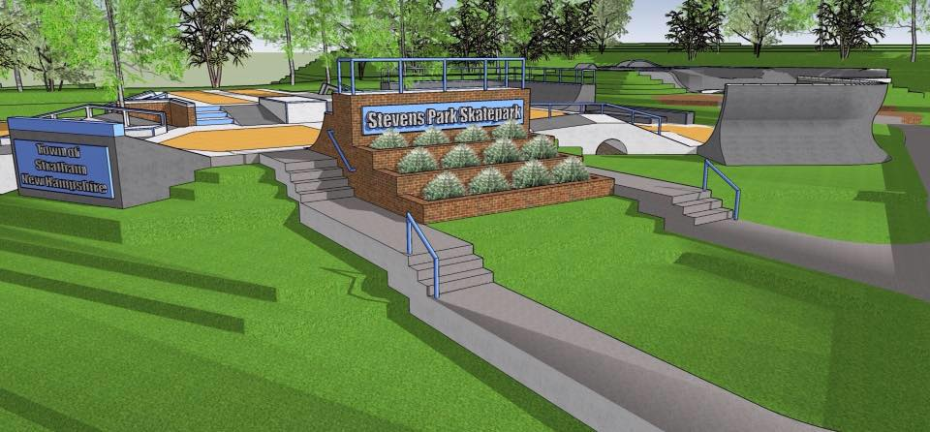

Our Story…

In spring 2017 residents came together with a common goal: to find a way to build a community skatepark in our town. After multiple meetings with the Board of Selectmen, Budget Committee, and finally the Town Vote in March 2018 the residents were able to solidify $35,000 from the town to begin the project.
Over the course of this next year the Stratham Skatepark Committee is hoping to raise money through various fundraising platforms in order to minimize tax payer contribution. The funds raised through this page will go directly towards the building of the roughly 7,500 sq ft park which we are planning to begin building in May 2019. To complete the project we estimate that we will need roughly $265,000. Whether you bike, scoot, skate, inline, or ride a unicycle you are an athlete and you are DESERVING of an amazing, safe place to practice your sport.
Thank you for your support and belief in the project.
Wondering where the funds that are raised will go? All money raised will go directly to the Town of Stratham under the Parks and Recreation Department.
Need more info on why a skatepark is important?
First it encourages a growth mindset. Perseverance, effort, grit, determination. If you’ve ever seen an athlete trying to learn a new trick you will see Growth Mindset in action. It doesn’t matter if it takes them 1000 hours to land the trick. It doesn’t matter if they fall. They keep pushing, keep trying, and never give up. At a skate park you are naturally taught how to keep persisting and carry on through the mental and physical barriers to success.
A skate park promotes physical health. Children skate for hours at a time and many several times a week. When we live in a state where 24% (nearly one quarter) of NH kids ages 10-17 are obese this is important. There are no coaches needed, no schedules needed. Put those IPads aside because all these athletes need are their helmets and their choice of ride (skateboard, bmx bike, in-lines, scooter).
A skate park promotes mental health. Riding significantly decreases stress and anxiety, promotes better sleep, increases memory. It is a unique activity because it combines extreme physical exertion with precise muscle coordination and balance. The complexity of performing tricks improves brain function at a fundamental level and stimulates new cell growth.
A skate park is a natural progression from playgrounds. Children utilize a skate park in much the same way as they do a playground. At a playground as well as at a skate park you see community, kids and adults talking, socializing, and connecting. At a skate park kids are free to explore. There’s no “wrong way”. There is no getting “cut” from the team. It’s not about who is good... no one is "left out" – All levels are accepted practicing together, encouraging one another to grow and learn. It’s simply about having fun, being with friends, and being creative. If you’ve ever had the opportunity to watch someone ride in a skate park it’s beautiful. Each athlete is an artist in how they interpret the skate park. The tricks they choose and the combinations they put together is an art form and in many ways it’s freedom.
I’m sure many of us watched the Winter Olympics this year. You may have seen that the United States Snowboarding team did very well. The United States skateboarding team is gearing up to take over the 2020 Olympics in Toyko. It will be the first time skateboarding is in the summer games!
There are many opportunities and places in town for team sports for our kids – baseball, softball, soccer, and others. But team sports are not for everyone and while all young kids are able to play these sports by middle school many are being burnt out of the sports they have been playing for years and others are being outcompeted. A skate park offers a place for these youth.
We have 10 playing fields for these traditional young athletes to practice. The time is now to fill in the gap for non-traditional sports and allow these athletes a place to safely practice their sport of choice.
A quote by Jim Rohn: “All good men and women must take responsibility to create legacies that will take the next generation to a level we could only imagine.” Let’s start that legacy today…

Let’s Build It…
If you are interested in supporting our mission to build a beautiful, community skatepark please reach out today. Together we can turn this…
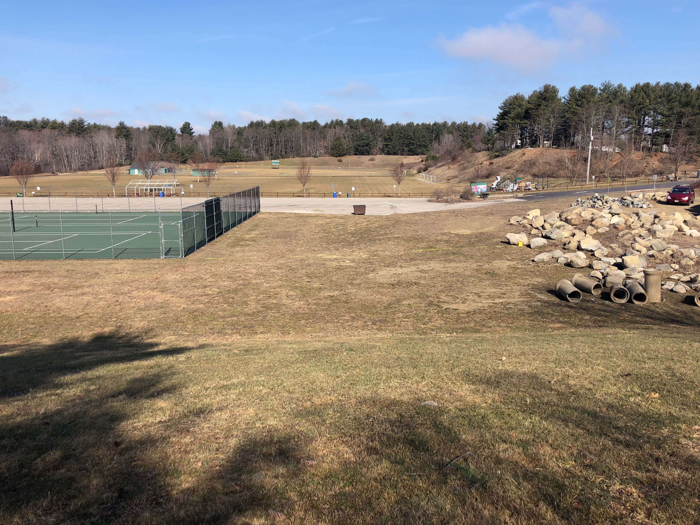
…into something AMAZING!

